Task 3: Dataset Preparation for Fine-Tuning

**Introduction:-**

Dataset preparation is a critical step in the machine learning pipeline, particularly for fine-tuning AI models. High-quality datasets ensure that models learn effectively and perform well in real-world applications. This document outlines techniques for developing and refining datasets, along with a comparison of various language model fine-tuning approaches.

**Techniques for Developing and Refining Datasets**

1. **Data Collection:-**

* **Diverse Sources**: Gather data from multiple sources such as databases, APIs, and web scraping to ensure diversity and representativeness. This helps in building robust models that generalize well to various inputs.
* **Relevance**: Focus on collecting data that is directly relevant to the specific tasks the model will perform. Irrelevant data can lead to poor model performance.

1. **Data Cleaning**:-

* Handling Inconsistencies: Remove duplicates, correct errors, and standardize formats to ensure data integrity. Cleaning data prevents skewed analysis and improves model reliability.
* Dealing with Missing Values: Use techniques like imputation or deletion to address missing data points. This is crucial as uncleaned data can produce incorrect outputs.

1. **Data Transformation:-**

* Normalization: Transform numerical values to a common scale, which helps in enhancing model performance, especially for algorithms sensitive to input ranges.
* Encoding Categorical Variables: Convert categorical variables into numerical formats (e.g., one-hot encoding) to make them suitable for machine learning algorithms.

1. **Data Validation:-**

* Automated Checks: Implement automated validation processes to ensure ongoing data quality. This includes checks for completeness, consistency, and accuracy.
* Monitoring Data Drift: Continuously monitor the dataset for changes in distribution over time, which can affect model performance. Adjustments should be made as necessary to maintain accuracy.

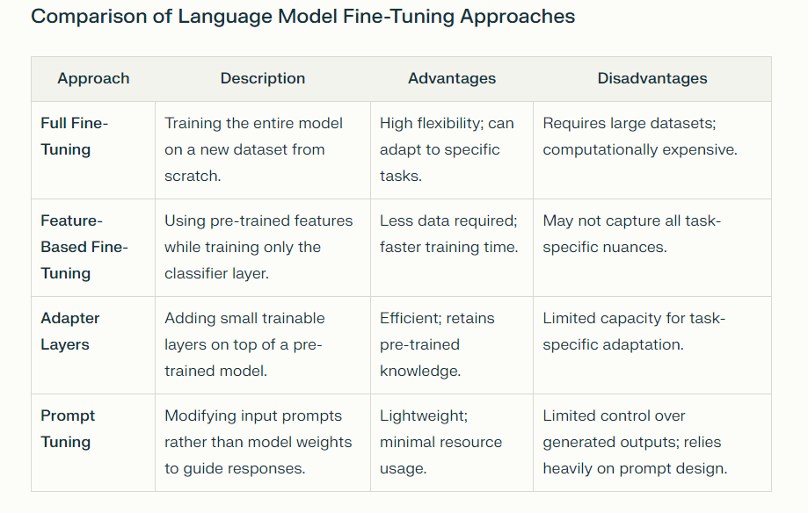

**Preferred Method:-**

Among these approaches, Adapter Layers are often preferred due to their balance between efficiency and effectiveness. They allow for task-specific fine-tuning without the need for extensive computational resources or large datasets while preserving the foundational knowledge of the pre-trained model.